Product Specification

Major parameter & Functions | Details
Applicable scene | Indoor/Outdoor
Operating system | Linux
Chip model | CV1821
Device storage | 128MB
Flash space | 32MB
Sensor model | F37
Sensor type | 1/2.7”CMOS
Maximum pixels | 2560（H）*1440（V）
Focus length | 4mm
Diagonal angle of view | 110°
Minimum illumination | 0.1Lux (color mode)  0.001Lux (black and white mode)  0Lux (fill light ON)
Number of fill light | 9 white lights，6 infrared lights
Night vision distance | 30m
Frame rate | Maximum 20 frames per second
TF storage card port | Support 16-128G storage card
Voice Pickup | Built-in microphone,  5m of pickup distance
External speaker | Support
Wired network | Support
Wi-Fi standard | N/A
Video format | H.264/H.265
Audio format | G711A/AAC
Video playback | Cloud storage/local storage playback
Working temperature | -20℃ to +60℃，<95%(without condensation)
Power supply | DC 12V/1A, POE
Waterproof and dustproof grade | IP66
Product certification | CCC
Installation method | Wall mounting, hanging
Major functions | Human shape detection
 | Motion detection
 | Voice detection
 | Motion Tracking
 | Face recognition/capture
 | Voice intercom (full duplex)
 | Full-color night vision, black and white night vision
 | Cloud playback /card playback
 | Alarm function (audible and visual alarm)
Product Photograph
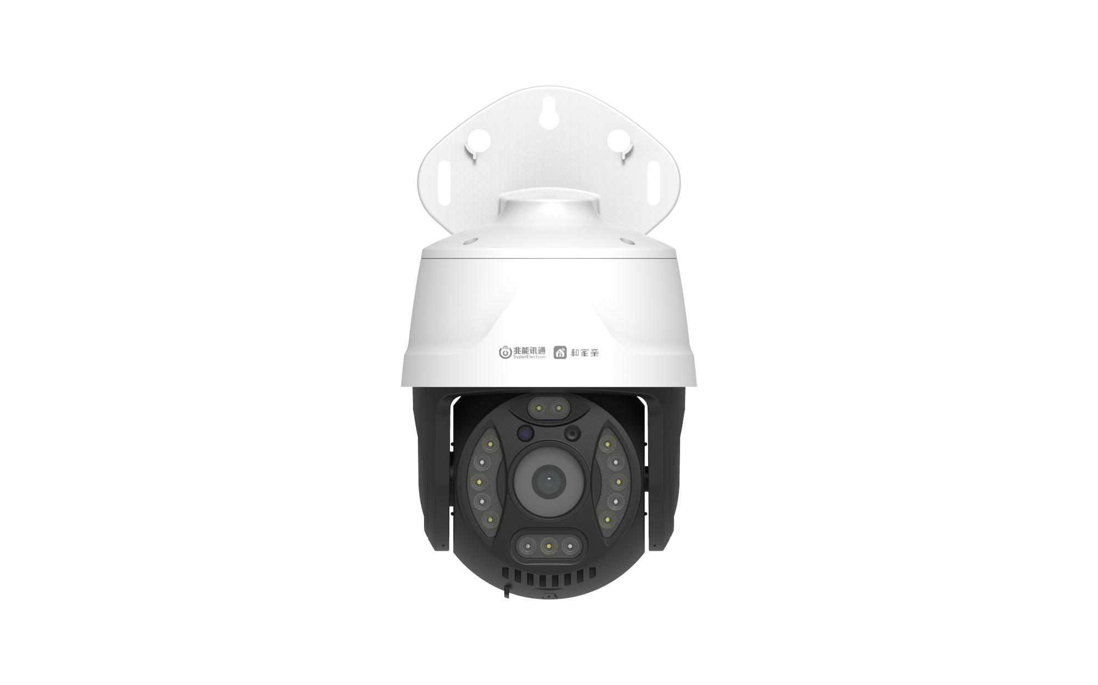 | 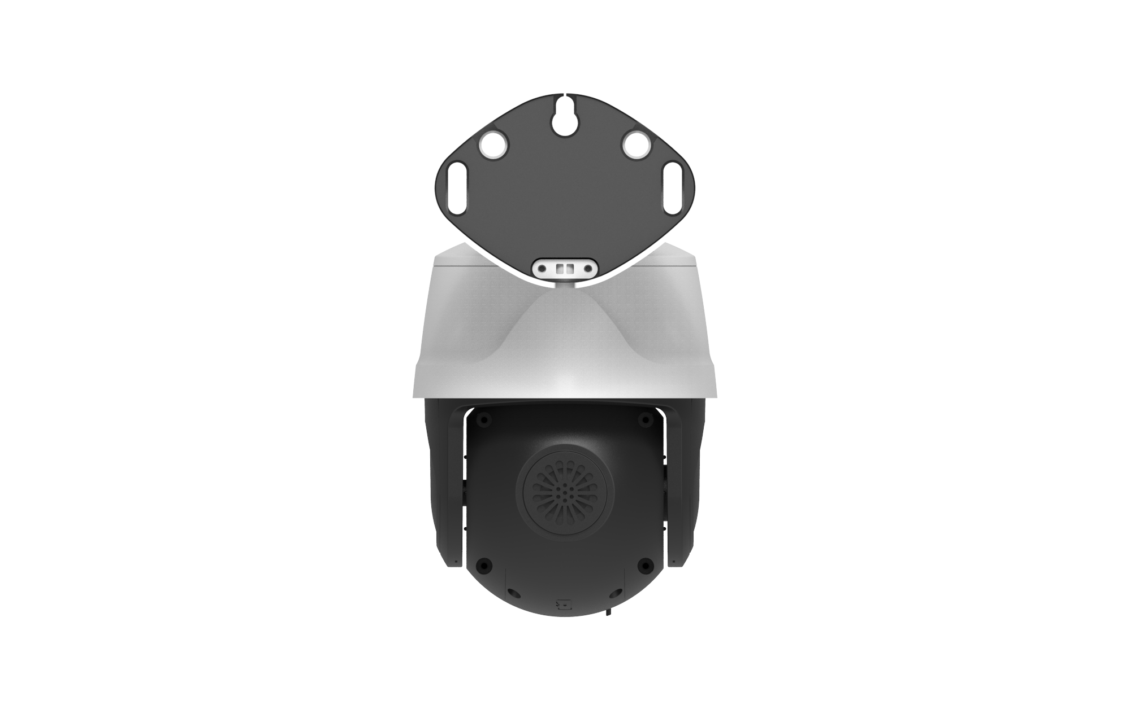
Front | Back

